**Wei Liang** **SP17**

**CST 2309-E286**

**Lab#1**

**Prof. Sancar Avcioglu Feb 1, 2017**

**Lab1 Q1:**

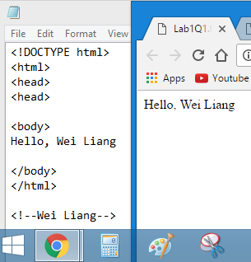

**Lab1 Q2:**

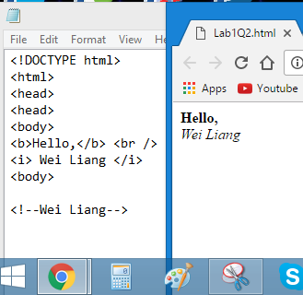

**Lab1 Q3:**

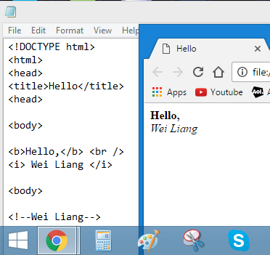

**Lab1 Q4:**

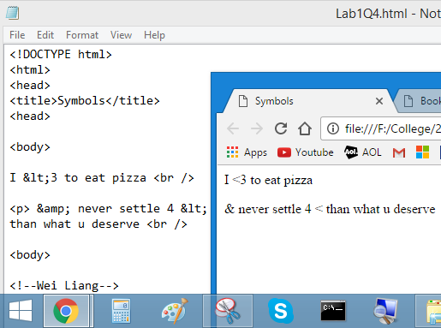

**Lab1 Q5:**

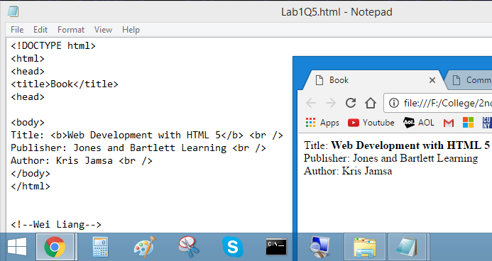

**Lab1 Q6:**

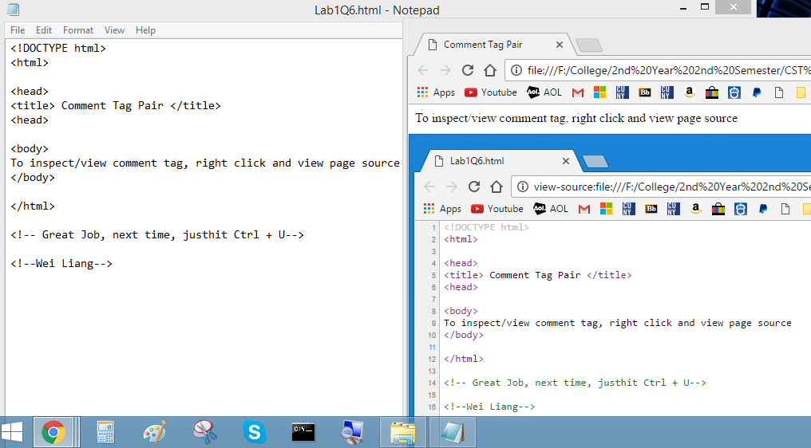

**Lab1 Q7:**

What’s Deprecated HTML code? Deprecated by definition generally means that something is acknowledged but discouraged. Thus, in Information Technology, this term Deprecation HTML, refers to a HTML tag/code that is available or allowed to be used but is not recommended. The main reason for it not being recommended is that certain numbers of elements and attributes in HTML 4.0, may have already been outdated by HTML 5.0, which result in some browsers whom don’t support the deprecate HTML code to be unable to read the code and the Website Layout becomes distorted.

(Answer from Page 21 of HTML 5 & Margaret Rouse from WhatIs.TechTarget.com)

**Lab1 Q8:**

What and Why FTP? FTP is an acronym that stands for File Transfer Protocol which is a program or tool that allows the user to easily move files from one computer to another; this can also be considered a Zip file. Thus, in the case of many Web Programmers, if they wish to create some pages for their site on their computer, they would need to use special FTP software which provides the rules that programs follow for uploading and downloading files to and from a remote server.

**Lab1 Q9:**

The <p> tag is used like a paragraph creator; it makes the browsers automatically add some space (margin) before and after each <p> element. Along with paragraph format, it also has text align format as well as color format.

<p style="background=color:yellow"> blah blah blah </p>

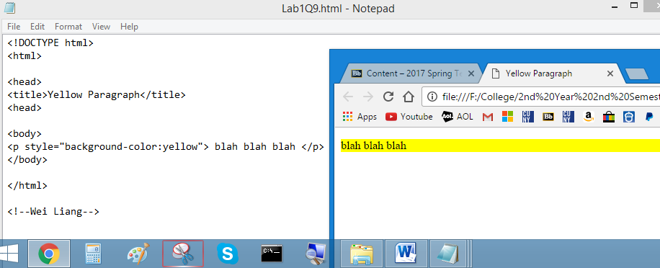

**Lab1 Q10: Nested HTML**

